**Lab Report No 3**

**Spectral Analysis of a random signal using MATLAB**

Provide .m file with detailed comments



FALL 2022

**Digital Signal Processing**

Submitted By: **Maaz Habib**

Registration No: **20PWCSE1952**

Section: **C**

**“On my honor, as student of University of Engineering and**

**Technology, I have neither given nor received unauthorized**

**assistance on this academic work”**

**Student Signature:**

**Department of Computer Systems Engineering**

**University of Engineering and Technology Peshawar**

**CSE 402L: Digital Signal Processing**

|  |  |  |  |  |
| --- | --- | --- | --- | --- |
| **Demonstration of Concepts** | **Poor (Does not meet expectation (1))**    The student failed to demonstrate a clear understanding of the assignment concepts | **Fair (Meet Expectation (2-3))**    The student demonstrated a clear understanding of some of the assignment concepts | **Good (Exceeds Expectation (4-5)**    The student demonstrated a clear understanding of the assignment concepts | **Score**  **30%** |
| **Accuracy** | The student completed ( <50%) tasks and provided MATLAB code and/or Simulink models with errors. Outputs shown are not correct in form of graphs (no labels) and/or tables along with incorrect analysis or remarks. | The student completed partial tasks (50% - <90%) with accurate MATLAB code and/or Simulink models. Correct outputs are shown in form of graphs (without labels) and/or tables along with correct analysis or remarks. | The student completed all required tasks (90%-100%) with accurate MATLAB code and/or Simulink models. Correct outputs are shown in form of labeled graphs and/or tables along with correct analysis or remarks. | **30%** |
| **Following Directions** | The student clearly failed to follow the verbal and written instructions to successfully complete the lab | The student failed to follow the some of the verbal and written instructions to successfully complete all requirements of the lab | The student followed the verbal and written instructions to successfully complete requirements of the lab | **20%** |
| **Time Utilization** | The student failed to complete even part of the lab in the allotted amount of time | The student failed to complete the entire lab in the allotted amount of time | The student completed the lab in its entirety in the allotted amount of time | **20%** |

**PROCEDURE:**

**Task 1:**

Create data with sampling frequency 1000 samples/sec. At time axis, take time from 0 to 0.25sec then make signal x of sine waves at 50Hz and 120Hz.

**Code:**

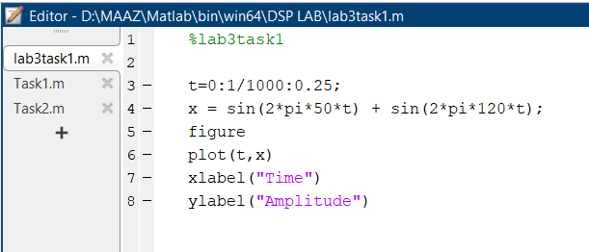

**Output:**

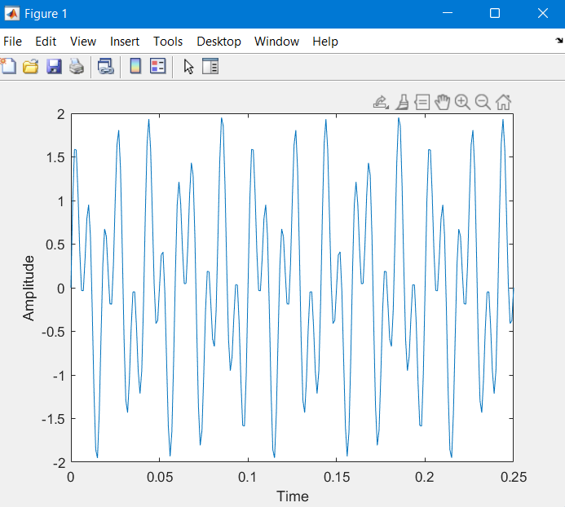

**Task 2:**

Add some random noise to the original signal x and make some Noisy signal y.

**Code:**

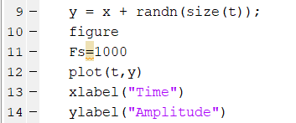

**NOISY SIGNAL:**

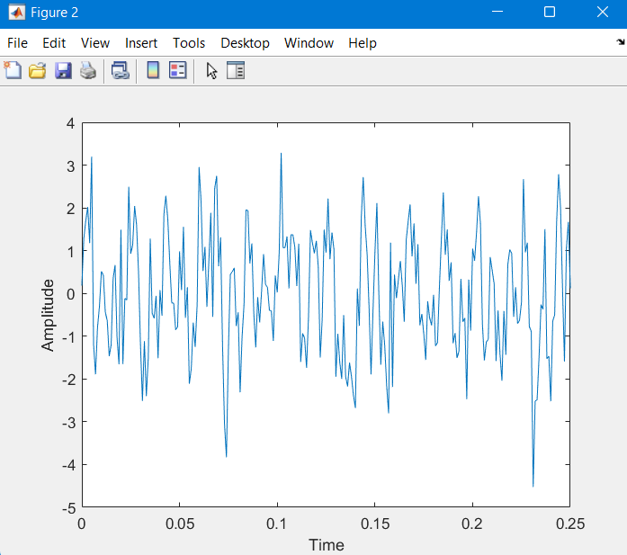

**Task 3:**

Finding the discrete Fourier transform of the noisy signal y

**Code:**

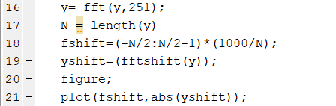

**FREQUENCY RESPONSE OF COMPOSITE SIGNAL(5Hz AND 120Hz):**

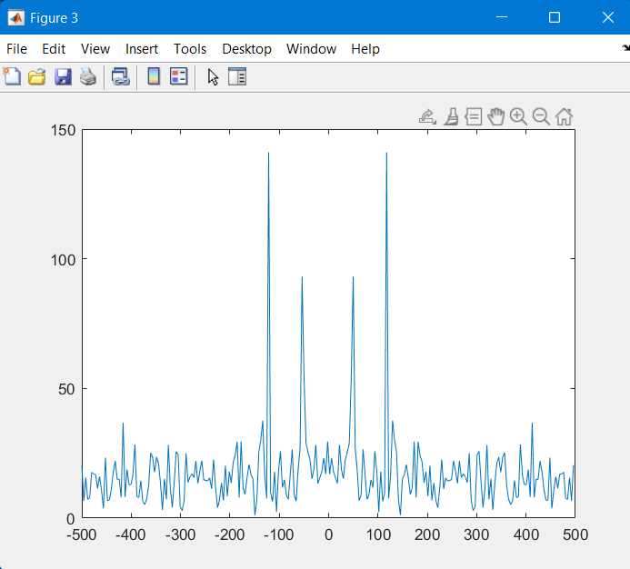

**Task4:**

**Compute the power spectral density, a measurement of the energy at various frequencies, using the complex conjugate (CONJ). Form a frequency axis for the first 127 points and use it to plot the result.**

**Code:**

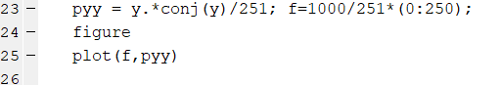

**POWER SPECTRA DENSITY:**

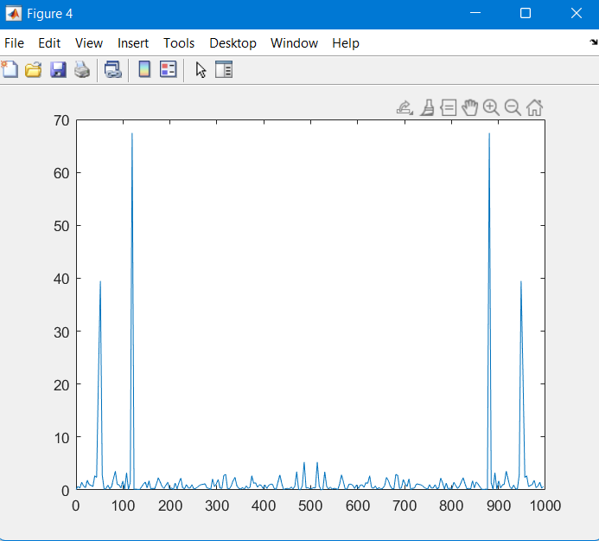

**PERIODOGRAM:**

**A periodogram is** **used to identify the dominant periods (or frequencies) of a time series**.

Compute and plot the periodogram using periodogram. Show that the two results are identical.

**Code:**



**PERIODOGRAM POWER SPECRA L DENSITY:**

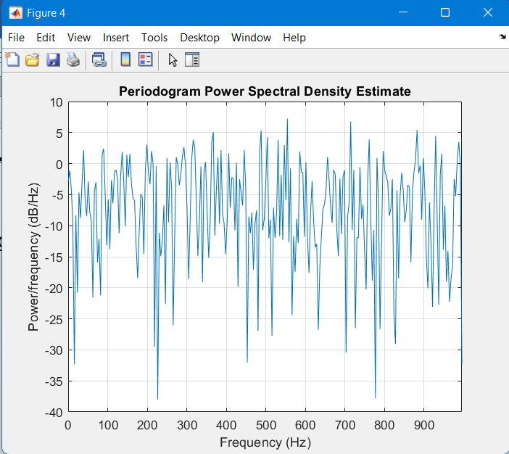

**Task6:**

Zoom in and plot only up to 200 Hz. Notice the peaks at 50 Hz and 120 Hz. These are the frequencies of the

original signal.

**Code:**



**POWER SPECTRAL DENSITY:**

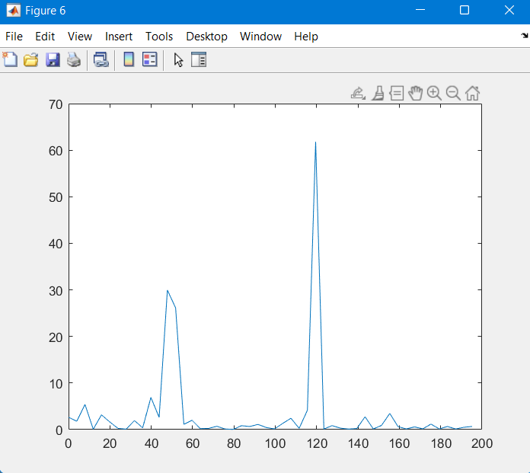

**Task7:**  
Final Remarks/Conclusion.

First, make a signal, x, containing sine waves at 50 Hz and 120 Hz.

Then, Add some random noise with a standard deviation of 2.

Then, Find the discrete Fourier transform of the noise signal.

Then, Compute the power spectral density.

After that, Compute and plot the periodogram using periodogram.

Finally, Zoom in and plot only up to 200 Hz.